22nd October 2018

**Mikel Azcona is Touring Car Europe Series Champion**

The TCR Europe series which has the Japanese premium tyre manufacturer YOKOHAMA as Official Tyre supplier concluded its season in Barcelona at the weekend. The 22 year old Spaniard Mikel Azcona achieved the crown after a nearly spotless performance on his maiden international season together with PCR Sport team, also facing their first international season making it an impressive exploit.

At the weekend racing in Barcelona, Azcona was entirely focused on the title and grabbing the necessary points, while letting the others fight for race positions. In race 2, eventually he drove his Cupra safe to the end in eighth place, right behind Jean-Karl Vernay, the only title contender left on the race and who finished runner up in the standings.

The others – Dušan Borković and Attila Tassi – had been eliminated during the first lap in a collision that was later investigated by the Stewards and considered as a normal racing incident.

With the title “battle” being decided by the placing, other drivers had an opportunity to shine.

Series newcomers Mike Halder and Ashley Sutton proved they have a place amongst the top-runners in TCR Europe. Halder, a title contender in TCR Germany, had been hired by the Hell Energy Racing with KCMG to help the team clinching the Teams’ title, and he successfully performed his duty driving his Honda Civic to a lights-to-flag victory that was worth the points needed to clinch the title. Sutton, a former BTCC champion and TCR UK race winner, conquered a well-deserved podium by finishing third, sandwiched between M1RA team-mates Dániel Nagy and the experienced Norbert Michelisz.

The series visited Circuit Paul Ricard in France and Circuit Zandvoort in the Netherlands in May, the legendary Spa- Fracorchamps in June, the Hungaroring in Hungary in July and TT Circuit Assen in the Netherlands in August before visiting the Italian, Autodromo di Monza in September, before the exciting conclusion at the weekend at the Circuito de Barcelona Catalunya in Spain.

Summing up the series finale a spokesman for YOKOHAMA Europe expressed delight at the high-level competition throughout the year and praised the efforts of all the teams and drivers. “Congratulations to Mikel Azcona and his team for a splendid season. The excellent performance of the teams and drivers has been matched by the high performance of our YOKOHAMA tyres in every race.” He added.

**Final Top 5 Driver standings**

1. Mikel Azcona 181 pts
2. Jean-Karl Vernay 159 pts
3. Dušan Borković 154 pts
4. Attila Tassi 153 pts
5. Dániel Nagy 138 pts

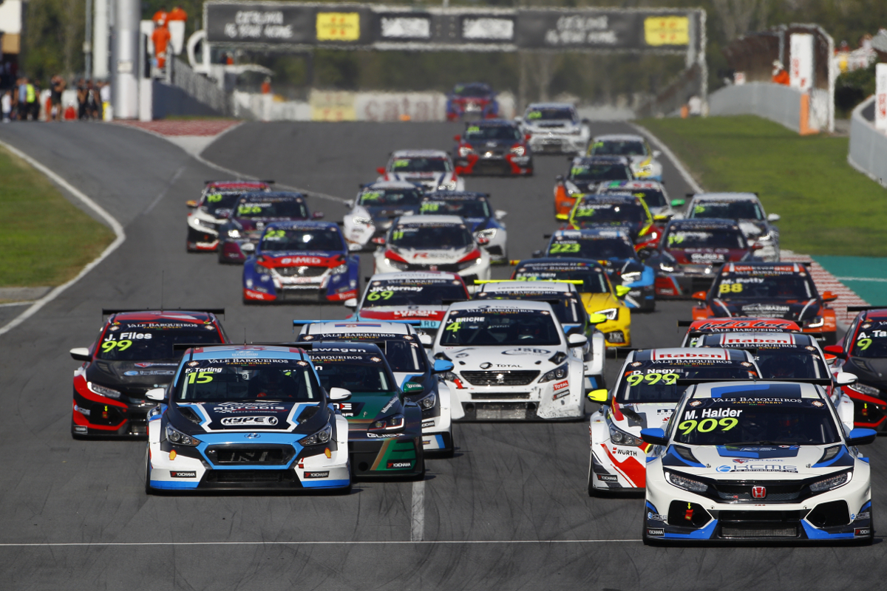

*Barcelona 2018 Race 2_Photo Andres Pardo Gomez*

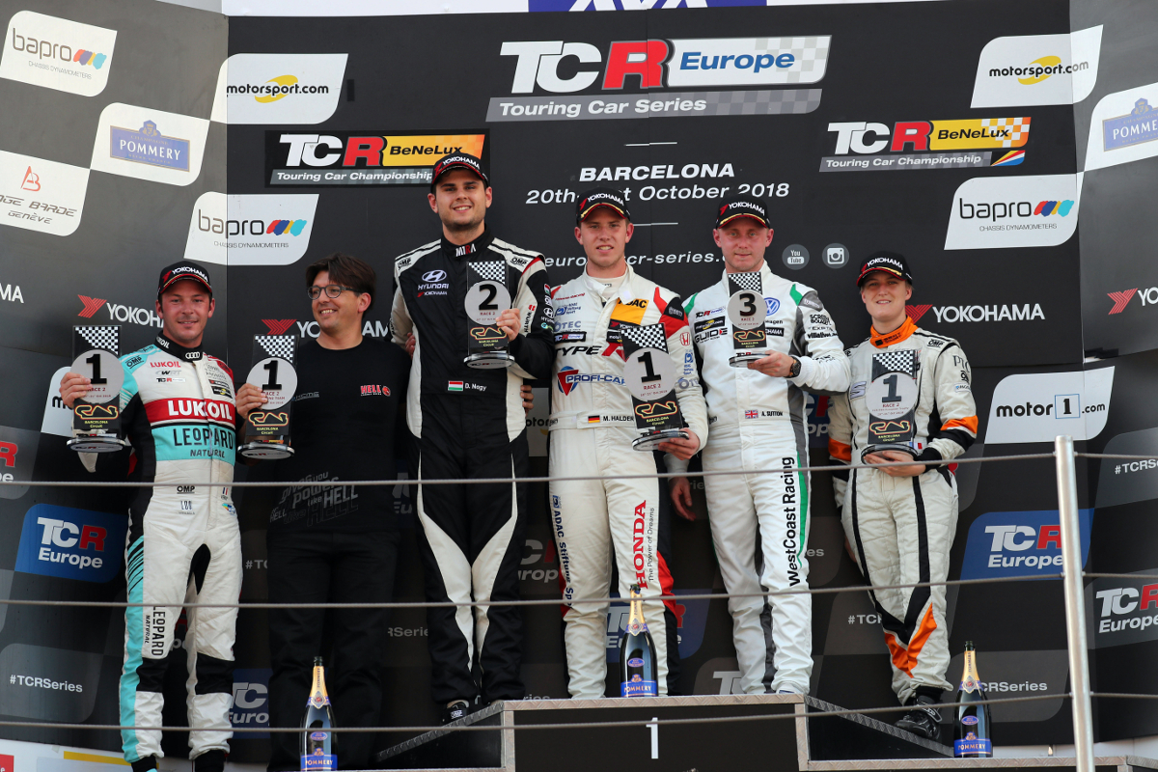

*Barcelona 2018 Race 2 October_Podium*